Mersenne Primes
# Source: AI Source: Provided by: [Data Path: Persons Table -> ID Column: 1, Name_En Column: Motasem Essam] -> From: [ChatGPT] on [7/13/2026]
A Mersenne prime is a prime number that can be written in the form
$$M_{n}=2^{n}-1,$$
where
- $n$is a positive integer, and
- $M_{n}$is itself prime.
Mersenne primes are named after the 17th-century French mathematician Marin Mersenne, who studied numbers of this form. They are among the most important classes of prime numbers and are closely connected to perfect numbers, cryptography, and the search for extremely large prime numbers.

Definition
# Source: AI Source: Provided by: [Data Path: Persons Table -> ID Column: 1, Name_En Column: Motasem Essam] -> From: [ChatGPT] on [7/13/2026]
A Mersenne prime is a prime number of the form
$$M_{n}=2^{n}-1,$$
where
- $n$is a positive integer,
- $2^{n}-1$is prime.

Rules for Mersenne Primes

1. The Number Must Be of the Form $2^{n}-1$
# Source: AI Source: Provided by: [Data Path: Persons Table -> ID Column: 1, Name_En Column: Motasem Essam] -> From: [ChatGPT] on [7/13/2026]
Every Mersenne prime must be expressible as
$$2^{n}-1.$$
Example
$$2^{5}-1=31.$$
Since
$$31$$
is prime,
it is a Mersenne prime.

2. The Exponent Must Be Prime
# Source: AI Source: Provided by: [Data Path: Persons Table -> ID Column: 1, Name_En Column: Motasem Essam] -> From: [ChatGPT] on [7/13/2026]
If
$$2^{n}-1$$
is prime, then
$$n$$
must also be prime.
However, a prime exponent does not guarantee a Mersenne prime.
Example
$$n=11 \\ 2^{11}-1=2047.$$
Since
$$2047=23×89,$$
it is not prime.

3. Not Every Prime Number Is a Mersenne Prime
# Source: AI Source: Provided by: [Data Path: Persons Table -> ID Column: 1, Name_En Column: Motasem Essam] -> From: [ChatGPT] on [7/13/2026]
Many prime numbers cannot be written in the form
$$2^{n}-1.$$
Example
$$19$$
is prime,
but there is no integer
$$n$$
such that
$$2^{n}-1=19.$$
Therefore,
19 is not a Mersenne prime.

4. Every Mersenne Prime Is an Odd Prime (Except None)
# Source: AI Source: Provided by: [Data Path: Persons Table -> ID Column: 1, Name_En Column: Motasem Essam] -> From: [ChatGPT] on [7/13/2026]
Since
$$2^{n}$$
is even for
$$n≥2, \\ 2^{n}-1$$
is always odd.
Therefore, every Mersenne prime is an odd prime.

5. Mersenne Primes Are Rare
# Source: AI Source: Provided by: [Data Path: Persons Table -> ID Column: 1, Name_En Column: Motasem Essam] -> From: [ChatGPT] on [7/13/2026]
Although there are infinitely many prime exponents,
very few produce Mersenne primes.
Only a small number of Mersenne primes are currently known.

6. Every Known Largest Prime Is a Mersenne Prime
# Source: AI Source: Provided by: [Data Path: Persons Table -> ID Column: 1, Name_En Column: Motasem Essam] -> From: [ChatGPT] on [7/13/2026]
The largest known prime numbers discovered so far are all Mersenne primes.
This is because numbers of the form
$$2^{n}-1$$
can be tested efficiently using the Lucas–Lehmer primality test.

7. It Is Unknown Whether Infinitely Many Mersenne Primes Exist
# Source: AI Source: Provided by: [Data Path: Persons Table -> ID Column: 1, Name_En Column: Motasem Essam] -> From: [ChatGPT] on [7/13/2026]
Mathematicians do not know whether infinitely many Mersenne primes exist.
This remains one of the major open problems in number theory.

First Mersenne Primes
# Source: AI Source: Provided by: [Data Path: Persons Table -> ID Column: 1, Name_En Column: Motasem Essam] -> From: [ChatGPT] on [7/13/2026]
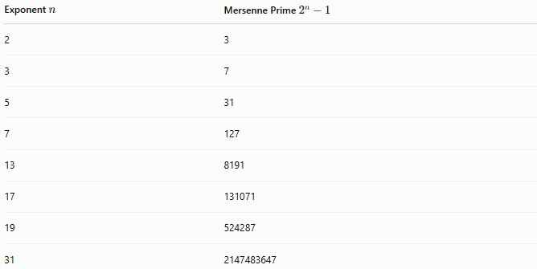
Exponent $n$ | Mersenne Prime $2^{n}-1$
2 | 3
3 | 7
5 | 31
7 | 127
13 | 8191
17 | 131071
19 | 524287
31 | 2147483647

Examples
# Source: AI Source: Provided by: [Data Path: Persons Table -> ID Column: 1, Name_En Column: Motasem Essam] -> From: [ChatGPT] on [7/13/2026]
Example 1
Determine whether
$$31$$
is a Mersenne prime.
$$31=2^{5}-1.$$
Since
$$31$$
is prime,
it is a Mersenne prime.

Example 2
Determine whether
$$127$$
is a Mersenne prime.
$$127=2^{7}-1.$$
Since
$$127$$
is prime,
it is a Mersenne prime.

Example 3
Determine whether
$$2047$$
is a Mersenne prime.
$$2047=2^{11}-1.$$
However,
$$2047=23×89.$$
Therefore,
2047 is not a Mersenne prime.

Example 4
Determine whether
$$8191$$
is a Mersenne prime.
$$8191=2^{13}-1.$$
Since
$$8191$$
is prime,
it is a Mersenne prime.

Example 5
Determine whether
$$19$$
is a Mersenne prime.
Although
$$19$$
is prime,
it cannot be written as
$$2^{n}-1.$$
Therefore,
it is not a Mersenne prime.

Example 6
Determine whether
$$3$$
is a Mersenne prime.
$$3=2^{2}-1.$$
Since
$$3$$
is prime,
it is a Mersenne prime.

Common Mersenne Primes
# Source: AI Source: Provided by: [Data Path: Persons Table -> ID Column: 1, Name_En Column: Motasem Essam] -> From: [ChatGPT] on [7/13/2026]
$$3, \\ 7, \\ 31, \\ 127, \\ 8191, \\ 131071, \\ 524287, \\ 2147483647.$$

How to Determine Whether a Number Is a Mersenne Prime
# Source: AI Source: Provided by: [Data Path: Persons Table -> ID Column: 1, Name_En Column: Motasem Essam] -> From: [ChatGPT] on [7/13/2026]
- Verify that the number can be written as
$$2^{n}-1.$$
- Check whether
$$n$$
is prime.
- Test whether
$$2^{n}-1$$
is prime.
- If both conditions are satisfied, the number is a Mersenne prime.
Example
Check
$$127. \\ 127=2^{7}-1.$$
Since
$$7$$
is prime and
$$127$$
is prime,
127 is a Mersenne prime.

Real-Life Applications
# Source: AI Source: Provided by: [Data Path: Persons Table -> ID Column: 1, Name_En Column: Motasem Essam] -> From: [ChatGPT] on [7/13/2026]
Mersenne primes are used in:
- Number theory research
- Searching for record-breaking prime numbers
- Cryptography research
- Primality testing
- Computational mathematics
- Distributed computing
- High-performance computing
- Algorithm optimization
- Mathematics education
- Theoretical mathematics

Real-Life Examples
# Source: AI Source: Provided by: [Data Path: Persons Table -> ID Column: 1, Name_En Column: Motasem Essam] -> From: [ChatGPT] on [7/13/2026]
1. Great Internet Mersenne Prime Search (GIMPS)
Thousands of computers around the world collaborate to discover new Mersenne primes using distributed computing.

2. Record Prime Discoveries
Nearly every largest known prime number has been a Mersenne prime because of efficient testing methods.

3. Perfect Number Research
Every known even perfect number is generated from a Mersenne prime using Euclid's formula.

4. Cryptography Research
Researchers study Mersenne primes to improve algorithms involving very large integers.

5. High-Performance Computing
Supercomputers test enormous Mersenne numbers to search for new prime numbers.

6. Mathematics Education
Mersenne primes provide classic examples when studying exponentiation, primality, and perfect numbers.

Common Mistakes
# Source: AI Source: Provided by: [Data Path: Persons Table -> ID Column: 1, Name_En Column: Motasem Essam] -> From: [ChatGPT] on [7/13/2026]
- Assuming every number of the form
$$2^{n}-1$$
is prime.
- Thinking every prime exponent produces a Mersenne prime.
- Believing every prime number is a Mersenne prime.
- Forgetting that the exponent must be prime.
- Assuming infinitely many Mersenne primes are known to exist.

Key Points
# Source: AI Source: Provided by: [Data Path: Persons Table -> ID Column: 1, Name_En Column: Motasem Essam] -> From: [ChatGPT] on [7/13/2026]
- A Mersenne prime has the form
$$2^{n}-1.$$
- If a Mersenne prime exists, then
$$n$$
must be prime.
- A prime exponent does not guarantee a Mersenne prime.
- Every Mersenne prime is an odd prime.
- Every known even perfect number is generated from a Mersenne prime.
- Whether infinitely many Mersenne primes exist remains an open problem.

Prime Numbers vs. Mersenne Primes
# Source: AI Source: Provided by: [Data Path: Persons Table -> ID Column: 1, Name_En Column: Motasem Essam] -> From: [ChatGPT] on [7/13/2026]
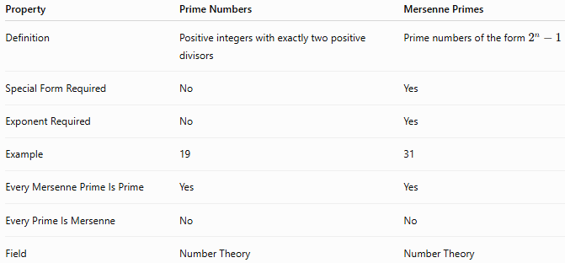
Property | Prime Numbers | Mersenne Primes
Definition | Positive integers with exactly two positive divisors | Prime numbers of the form $2^{n}-1$
Special Form Required | No | Yes
Exponent Required | No | Yes
Example | 19 | 31
Every Mersenne Prime Is Prime | Yes | Yes
Every Prime Is Mersenne | No | No
Field | Number Theory | Number Theory

Conclusion
# Source: AI Source: Provided by: [Data Path: Persons Table -> ID Column: 1, Name_En Column: Motasem Essam] -> From: [ChatGPT] on [7/13/2026]
A Mersenne prime is a prime number of the form $2^{n}-1$, where $n$is a positive integer and the resulting value is also prime. These primes are among the most important special classes of prime numbers because they are closely connected to perfect numbers, efficient primality testing, and the discovery of the largest known prime numbers. Although many Mersenne primes have been found, mathematicians still do not know whether infinitely many Mersenne primes exist, making them a central topic of research in number theory.

